H.T No
Regulations:
A18

Sreenidhi Institute of Science and Technology
(An Autonomous Institution)
Code No: 7K301 Date: 03-Oct-2020 (FN)

B.Tech II-Year I-Semester External Examination, October - 2020 (Supplementary)
INTRODUCTION TO SOLID MECHANICS (CIVIL)

Time: 2 Hours Max.Marks:70

Note: a) No additional answer sheets will be provided.
b) All sub-parts of a question must be answered at one place only, otherwise it will not be valued.
c) Missing data can be assumed suitably.

ANSWER ANY FIVE QUESTIONS. EACH QUESTION CARRIES 14 MARKS.

1. | a) | Explain stress – strain diagram with neat sketch. | [7M]
 | b) | A suspended bar system consists of two cross-section as shown in fig.11.b. Initially its lower surface is 0.8 mm above the ground surface. Determine the reaction of the lower support and the stress in each section when a load is applied as shown in figure. Take E=205 kN/mm²  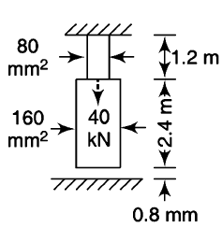  Fig. 11.b | [7M]
2. | a) | Draw shear force and bending moment diagram for the simply supported beam as shown in fig.12.a.  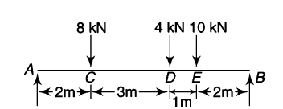  Fig. 12.a | [7M]
 | b) | Derive the relation between Shear Force and Bending moment. | [7M]
3. | a) | A steel rod is placed inside a brass tube. Both are the same length and have their axes parallel to each other, but are 5 mm apart. The inside and outside diameters of the tube are 48 mm and 56 mm, respectively whereas diameter of the rod is 28 mm. The ends of both are covered by rigid plates through which a compressive force of 50 kN is applied acting along the axis of the tube. Find the maximum and minimum longitudinal stresses in the tube and the rod. E_{s} = 210 N/mm² and E_{b} = 95 N/mm² | [7M]
 | b) | A bar of T – section symmetrical about the vertical center line has the flange 160 mm and 20 mm thick and the web 120 mm deep and 20 mm thick. The member is acted upon by a longitudinal pull p which acts on the section at a point on the vertical center line and is 50 mm from the bottom edge of the web. Determine the magnitude of the maximum pull which can be applied if the maximum allowable tensile stress on the section is 80 N/mm². Also, find the minimum stress on the section when the pull p is transmitted. | [7M]
4. | a) | A cantilever beam of span L carries a UDL of w kN/m. derive the general equation for slope and deflection along the length of the beam and find the slope deflection at the free end. EI is constant. | [7M]
 | b) | State and prove the Maxwell’s reciprocal deflection theorem. | [7M]
5. | a) | Explain the concept of the ellipse of stress. | [7M]
 | b) | The stresses on two mutually perpendicular planes through a point in a body are 80 N/mm² and 50 N/mm² both tensile. Determine the maximum value of the permissible principle stress is limited to 120 N/mm². What will be the inclination of the principal stress and the magnitude of the maximum shear stress? | [7M]
6. | a) | At a point in a stressed material, the three principal stresses are 90 N/mm² (tensile), 60 N/mm² (tensile) and 30 N/mm² (compressive). Find the factor of safety if the yield stress is 230 N/mm² and v=0.3 by the principal stress, shear stress, and principal strain theories. | [7M]
 | b) | Explain with examples the limitations of the shear stress distribution equation. | [7M]
7. | a) | Define the terms stress, strain, bulk modulus, modulus of elasticity and modulus of rigidity. | [7M]
 | b) | Draw SFD and BMD for a beam 5 m long and loaded as shown in fig.17.b  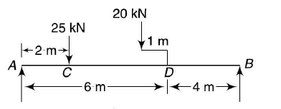  Fig. 17.b | [7M]
8. | a) | The distance between the supports of a simply supported beam is I. the beam has two equal overhangs of length L/3 over each support. The beam carries each support a point load 2w at the center and a point load W at each end. Determine i) the slope at the ends and at supports and ii) the deflection at ends and at the center. | [9M]
 | b) | State the major difference in Mohr’s circles for stress and strain. | [5M]

-- 00 -- 00 –

